|  |  |  |  |  |  |
| --- | --- | --- | --- | --- | --- |
| Date | 24-Nov-22 | | | Tester Name | Mayuri Patel |
| Environment | Penfax - Test | | | Login used |  |
| Operating System | Select OS | Version: | Update: | | |
| Software Used | Select Software | Version: | Update: | | |
| Select Software | Version: | Update: | | |
| Release version | 22.4.1 | | | | |
| Title |  | | | | |
| Test Type | Regression | | | | |
| Test Scenario | Add a primary MEPP Beneficiary – PENWEB | | | | |
|  |  | | | | |
| Expected Results |  | | | | |
| Pass/Fail | Pass | | | JIRA# | N/A |

Describe your steps with screenshots:

Search for a member to add a primary beneficiary

Open that member in Planet member MEPP

Under Beneficiary tab

Add/Change Beneficiary

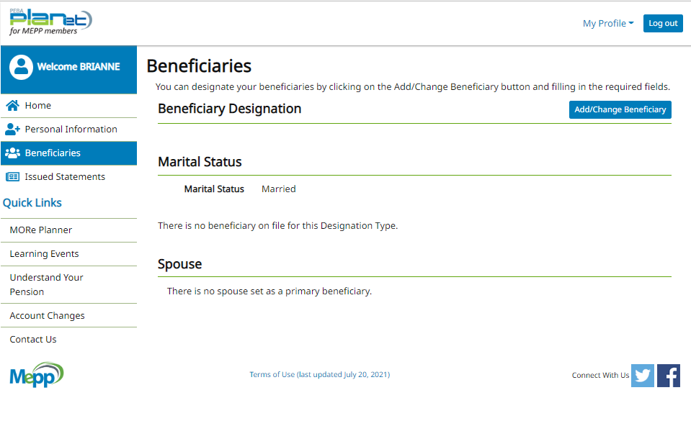

If Spouse is added on account then it will automatically add spouse as a primary MEPP beneficiary

Spouse is already there

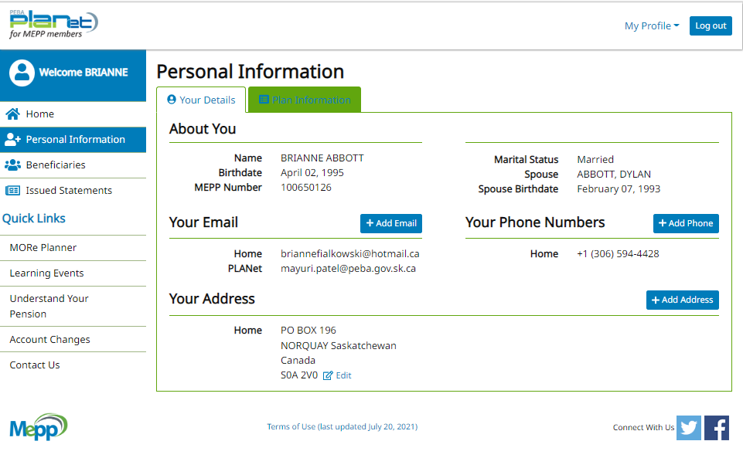

Add New Beneficiary

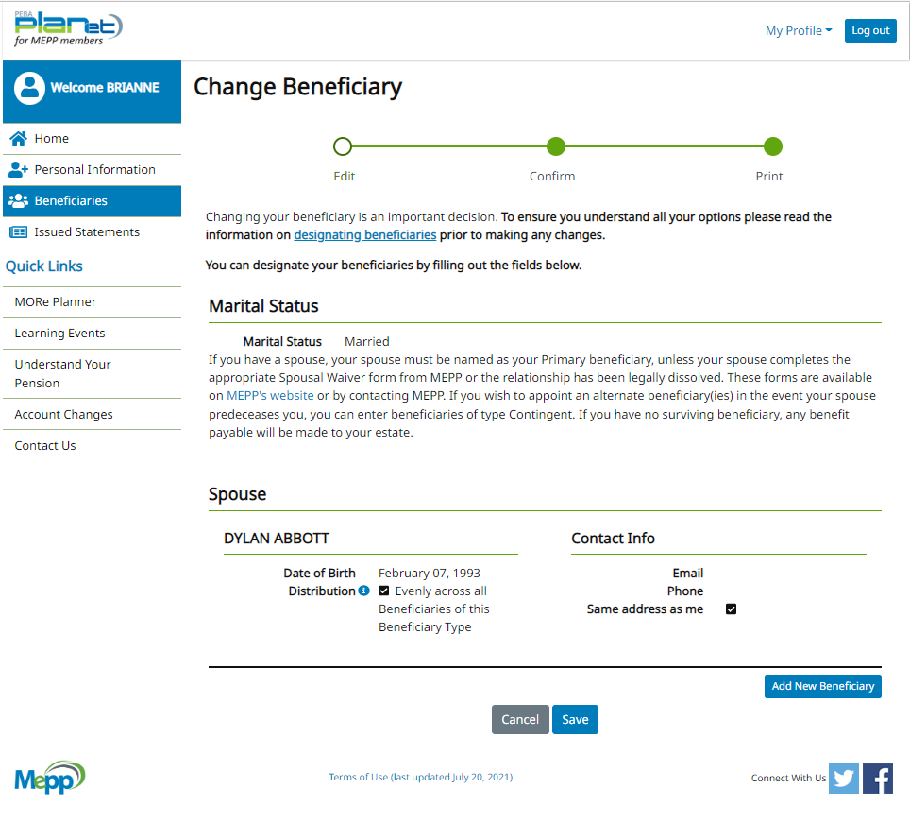

Save & Confirm

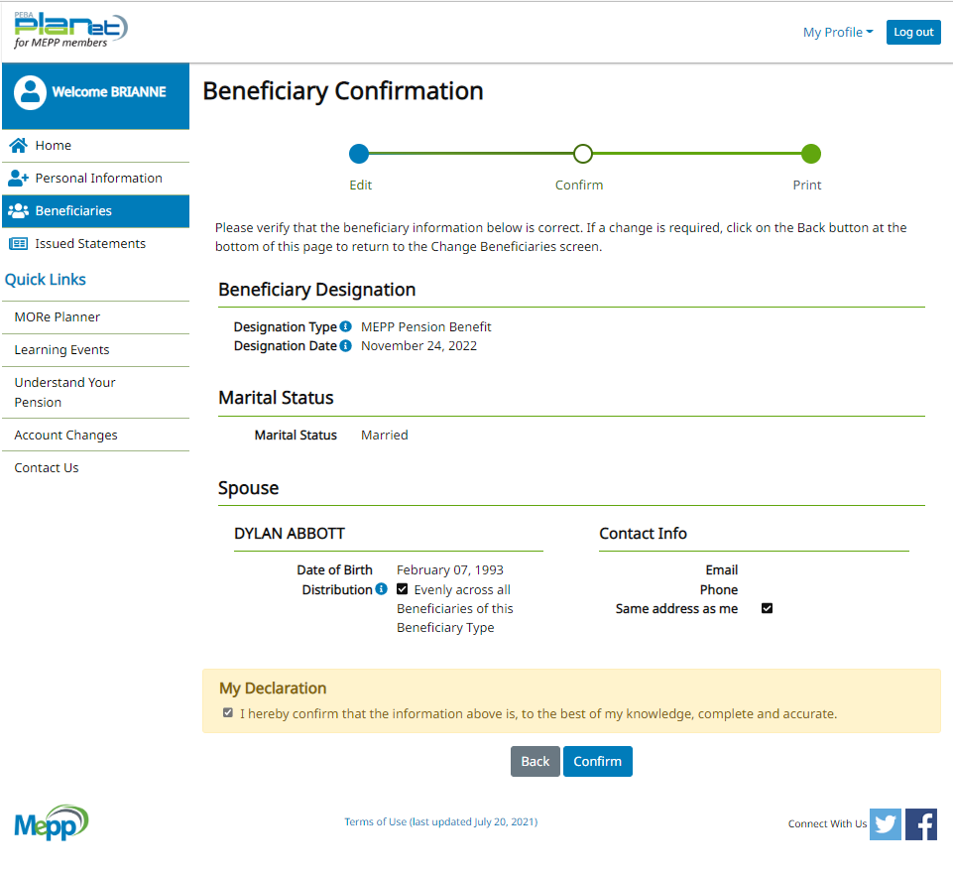

Print if needed

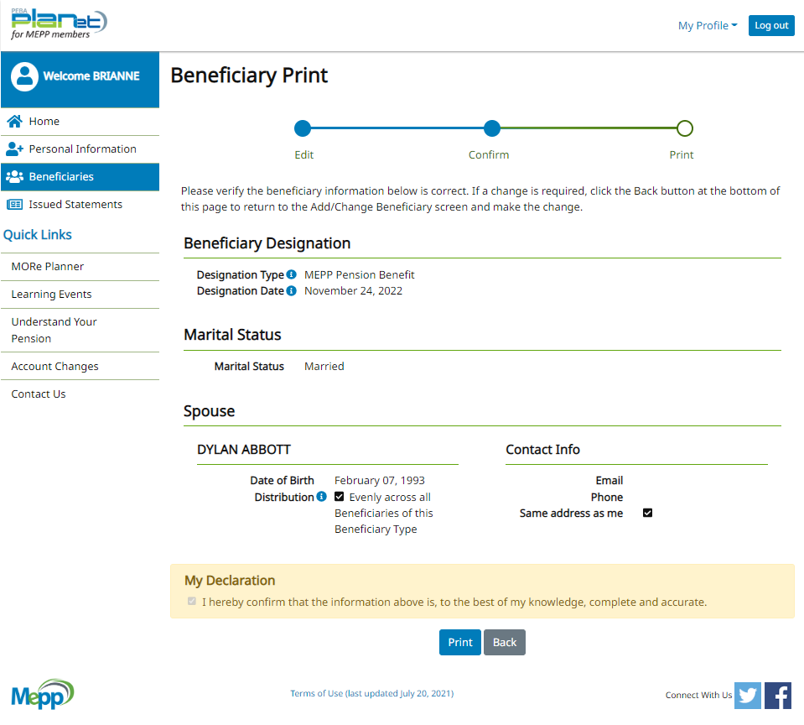

Refresh and a new Primary Beneficiary is added

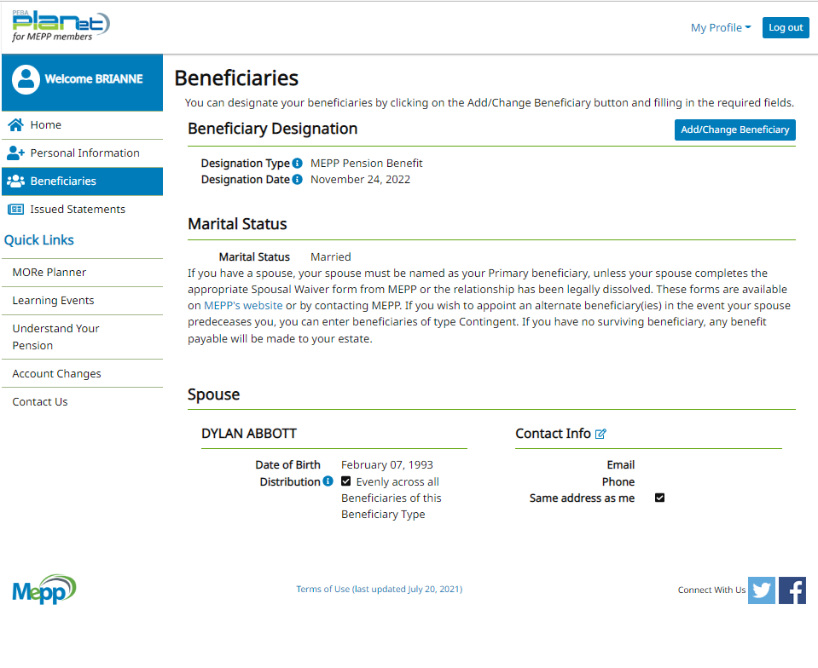

Pen fax before changes

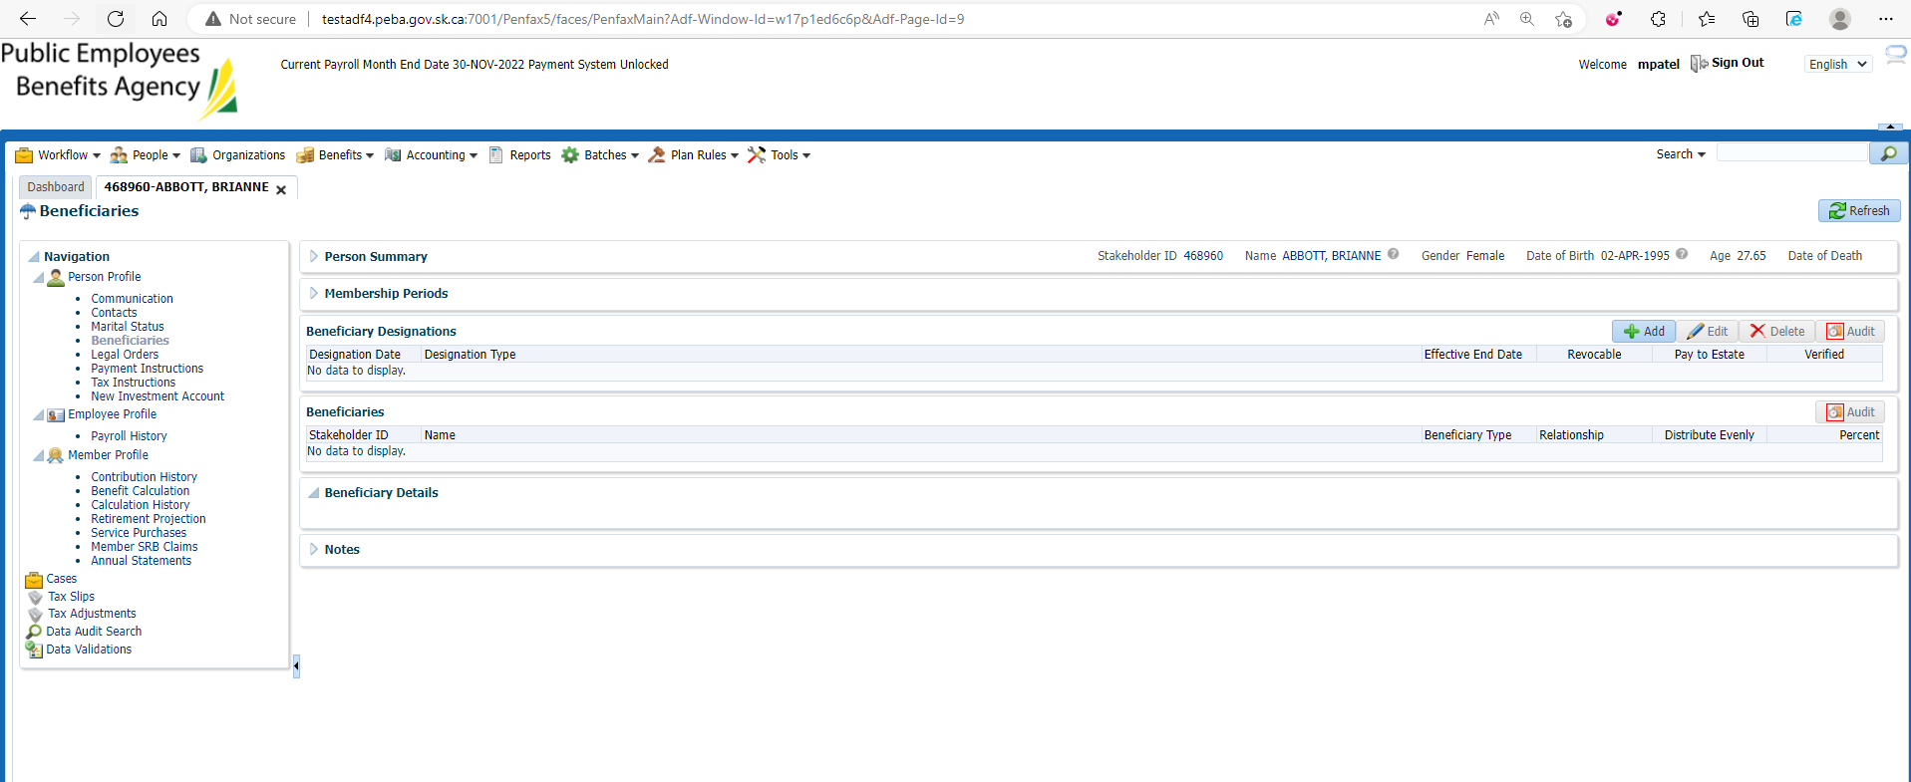

Changes are reflected in Pen fax

